AC and DC Black Start Function

Prepared By | Berke KÜÇÜKSAĞIR | Date | 15.02.2026
Approved By | Uğur KAZANCIOĞLU | Date | 15.02.2026

Revision History
Version | Date | Section | Change Details
V1.0 | 15.02.2026 | All | Initial version

Contents
- Overview of AC and DC Black Start Function 4
  - AC Black Start 4
  - DC Black Start 4
- Black Start Capability of the MPCS Series 4
  - Power Supply Systems for MPCS 4
  - Software for MPCS Black Start 4
- PCS Black Start Setting 4
  - MPCS-1725-S Black Start Setting 4
    - Fiber Communication Master/Slave Selection 4
    - Carrier Synchronization Role Setting 5
    - Carrier Synchronization Mode Setting 5
    - Off-Grid Acceleration Rate Setting 6
  - EMS Operation Steps for Black Start 6
    - Synchronous Start 6
    - Asynchronous Start 6

Overview of AC and DC Black Start Function

AC Black Start
AC black start relies on traditional AC power sources (for example, hydroelectric units or diesel generators) as the "starting power source" to gradually restore the grid through AC transmission lines. This function requires that the synchronous generator unit has self-starting capability and the ability to gradually drive other generator units and loads to form a stable AC grid.

DC Black Start
DC black start utilizes DC power sources (for example, energy storage systems, HVDC, or flexible VSC-HVDC) as the initial power source to supply power to unpowered areas through DC transmission channels. This function relies on converter stations to convert DC to AC for local load use or directly restores critical facilities through a DC microgrid.

Black Start Capability of the MPCS Series

Power Supply Systems for MPCS
The control system of MPCS can be powered by an external power supply in AC black start application scenarios, or by an internal power supply in DC black start application scenarios where only a DC source (energy storage system) is available.

Software for MPCS Black Start
Depending on the actual load conditions, there are two black start methods:
Method 1: Energy storage unit 1, which has droop characteristics and zero-start step-up capability, is selected as the black start source. It quickly and stably completes self-starting and provides frequency and voltage support for other loads in the microgrid. Other energy storage units, after grid synchronization, operate in droop mode together with unit 1 to complete parallel networking. This method increases the microgrid system's power generation and load-carrying capacity, and enhances the system's ability to withstand power impacts from other loads and the black start source.
Method 2: All energy storage units are black-started synchronously. In scenarios with complex load conditions, energy storage units in the same microgrid are required to start synchronously to meet load-carrying capacity requirements. In this case, the EMS must perform unified scheduling for startup, standby, and operation to meet the needs of synchronous soft start and load carrying.

PCS Black Start Setting

MPCS-1725-S Black Start Setting
Black start parameter setting

Fiber Communication Master/Slave Selection
Choose Parameter Setting > Manufacturer > F0 > F0_08 > Fiber Comms M/S Selection. For hard parallel connection, set the master as master and the slave as slave; otherwise, set as single.

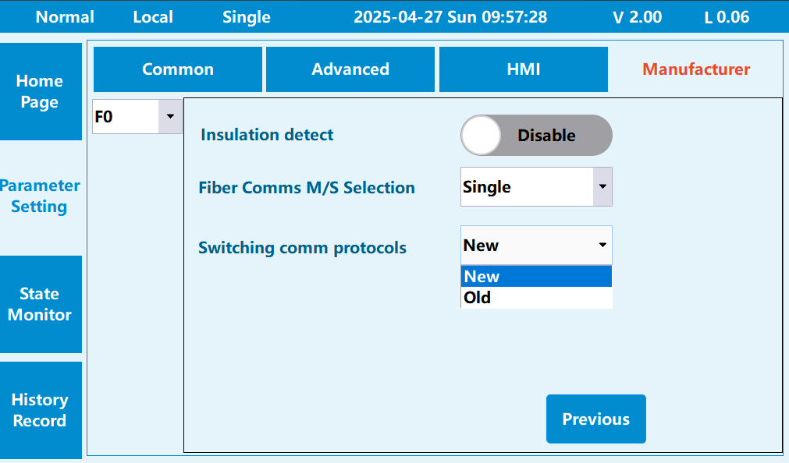

Carrier Synchronization Role Setting
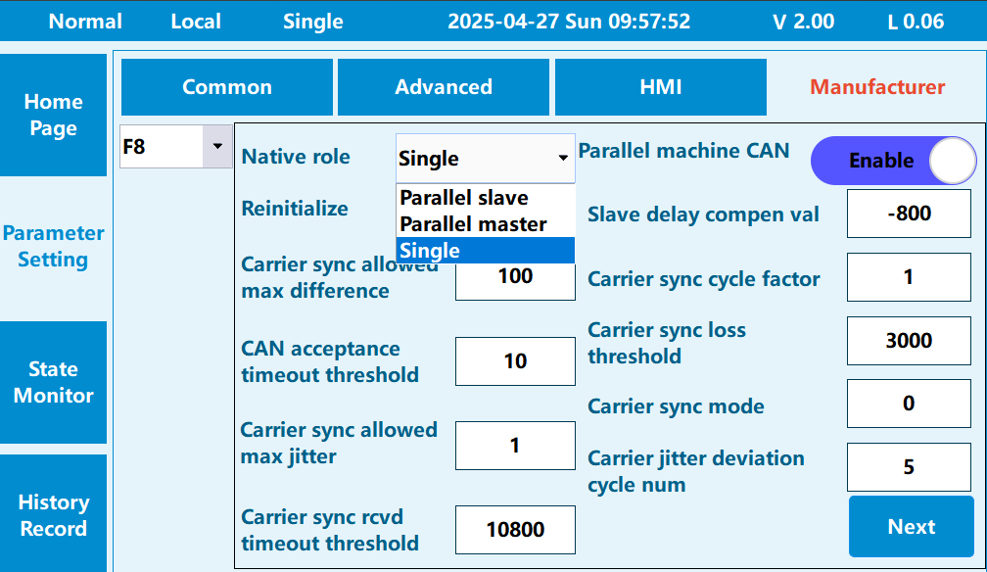
Choose Parameter Setting > Manufacturer > F8 > F8_00, and set Native role to Parallel master. Set the other PCS in parallel as Parallel slave.

Note: If there are four PCS units under one transformer, set one as the master and the others as slaves.

Carrier Synchronization Mode Setting
Choose Parameter Setting > Manufacturer > F8 > F8_24, and set Carrier sync mode to HDIDO. Set the carrier sync mode of the other PCS in parallel to HDIDO.

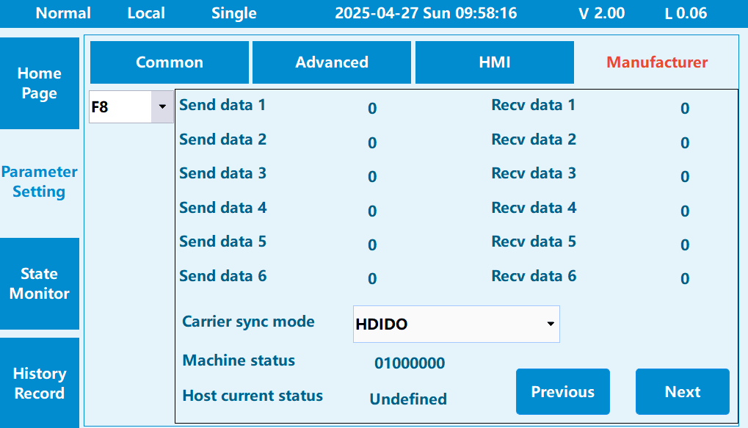

Off-Grid Acceleration Rate Setting
Choose Parameter Setting > Manufacturer > FE > FE_32, and set Off-grid acceler rate to 0.02.

EMS Operation Steps for Black Start

Synchronous Start
To minimize the pulsing time difference between PCS units, all PCS units must first enter standby mode during synchronous start. After confirming all PCS units are in standby, issue the start command.
For scenarios with large transformer capacities, multiple PCS units need to start simultaneously to support the inrush current during transformer excitation. The EMS synchronously sends start commands to the PCS units, with a maximum communication error among all PCS units preferably less than 100 ms.

Asynchronous Start
Asynchronous start involves starting PCS units one by one. The EMS sends start commands to each PCS sequentially, starting the second unit after the first is started, and so on, until all units are started.
This condition is suitable for black start scenarios with relatively small capacity, where a single PCS unit can complete the black start of the entire station's equipment or load.

